COMMANDS

AND

CONSTRIANTS

S.R.TAANUSRI

1.GROUP BY

* It helps to get desired value from two tables based on the attributes specified by user.
* The attributes include COUNT,AVG,MAX,MIN.

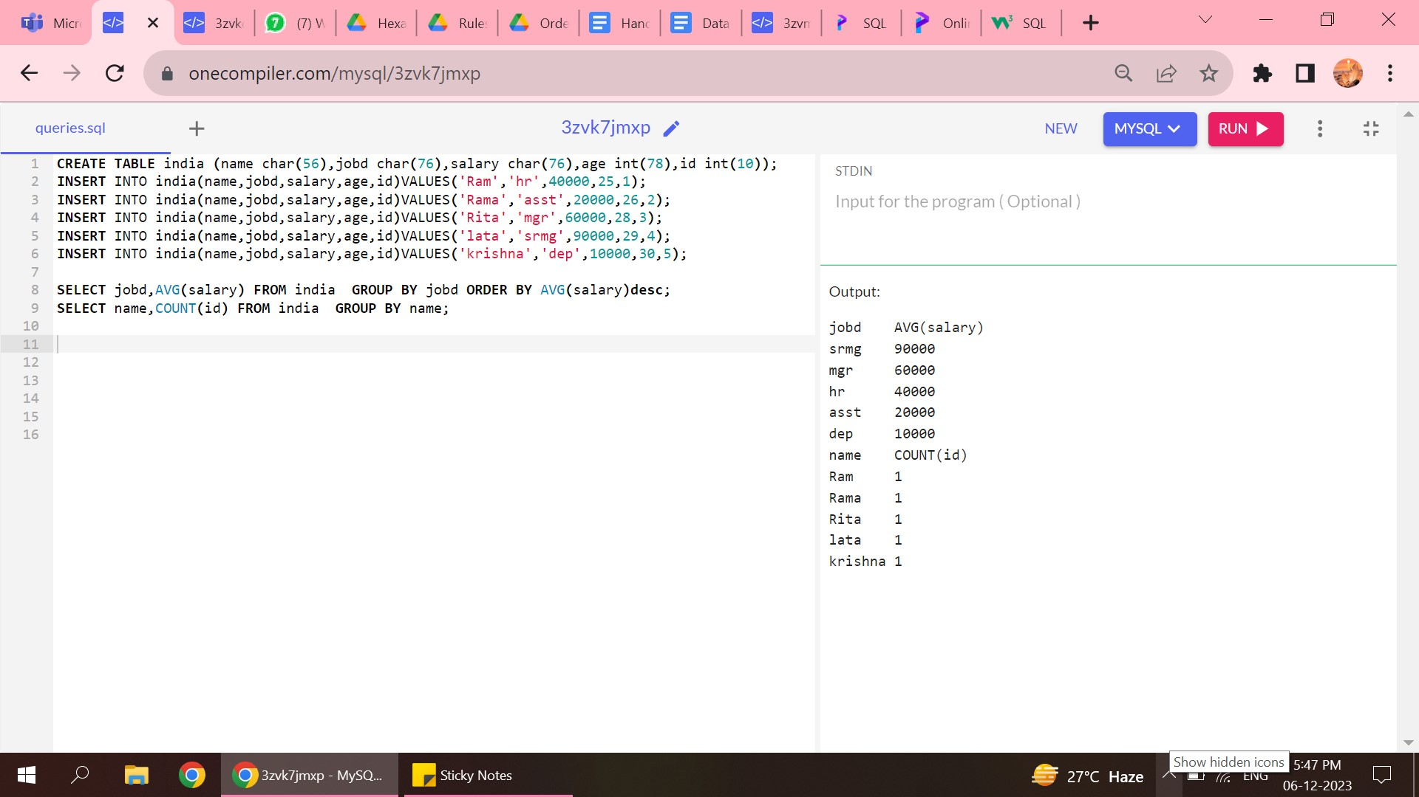

2.HAVING

* Based on the group by command the desired column is drawn from the table by using HAVE clause the specific condition that is needed.
* The column fetches value only if the condition specified is met.

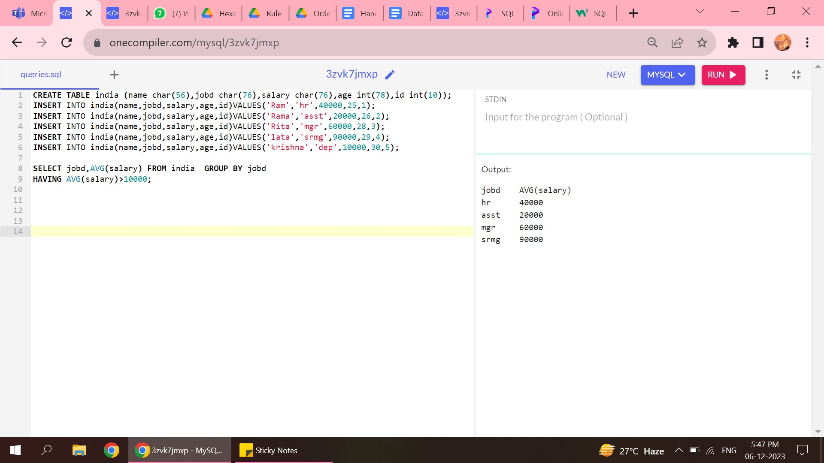

TML COMMANDS

1.COMMIT AND ROLLBACK

* The commit command helps all the transactions to be saved in the database.
* The rollback command helps the transaction made to be removed from database that has been done .

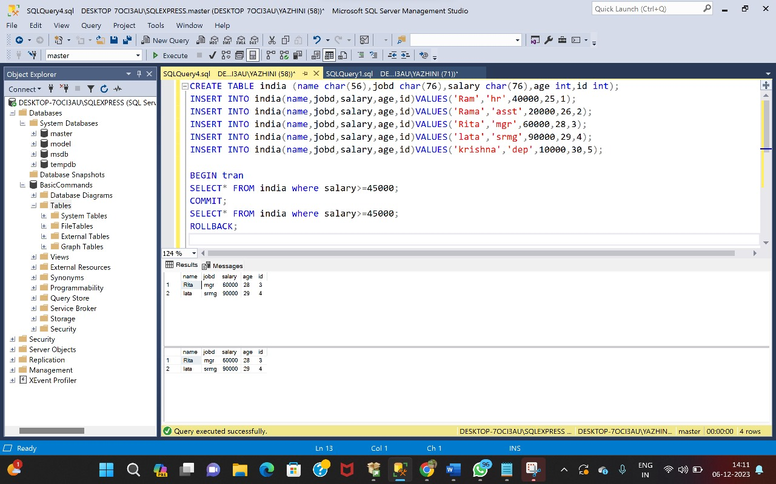

2.SAVE POINT

* The command helps to rollback the transaction to the particular point.
* Does not rollback the entire transaction.

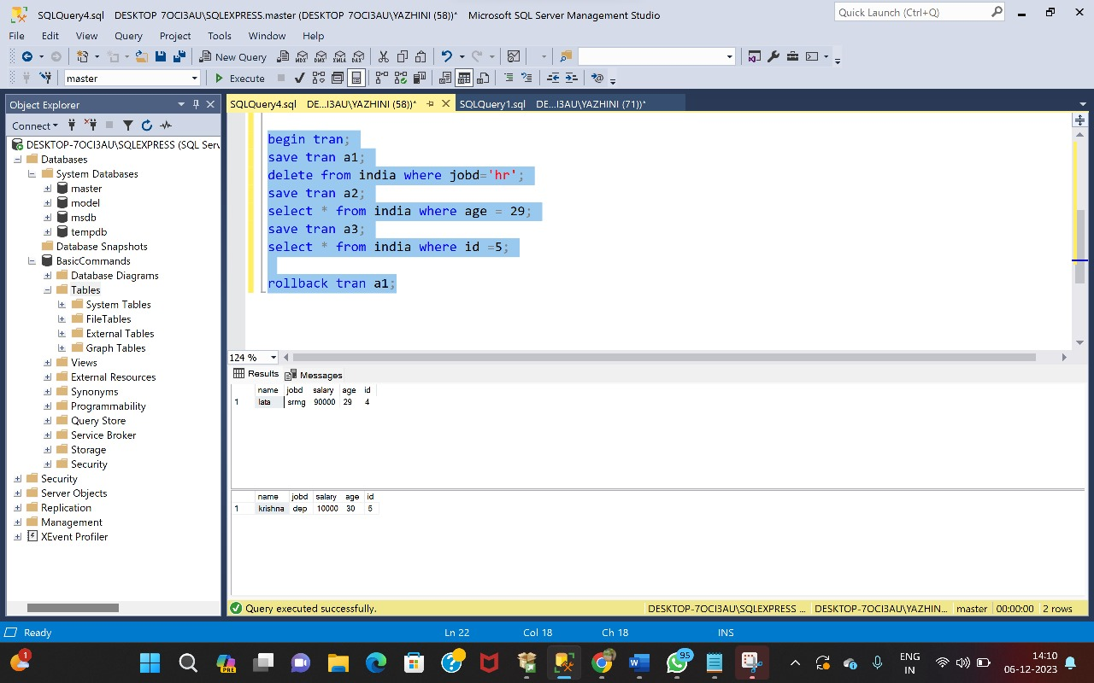

SET OPERATORS

1.UNION

* The command helps to combine two tables with same number of columns.
* It does not allow duplicate value.

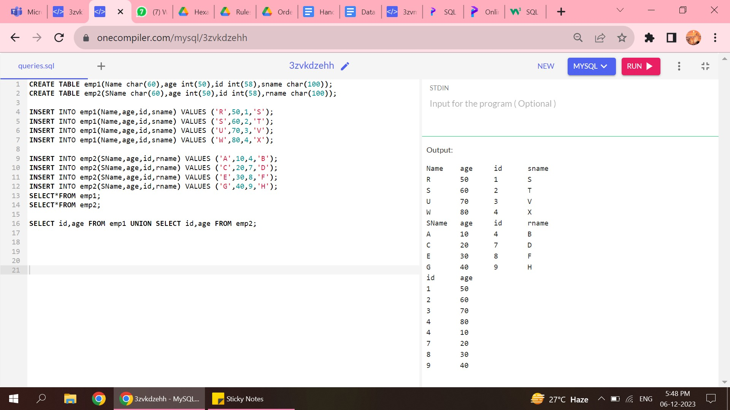

2.UNION ALL

* The only difference between UNION and UNION ALL is this allows the duplicate columns also to be printed.

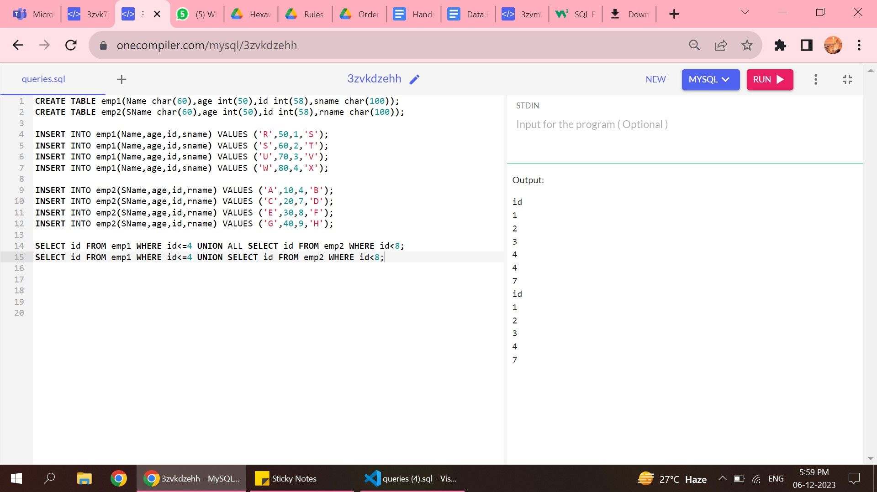

3.INTERSECTION

* The two column with same values in two tables can be combined using this keyword.

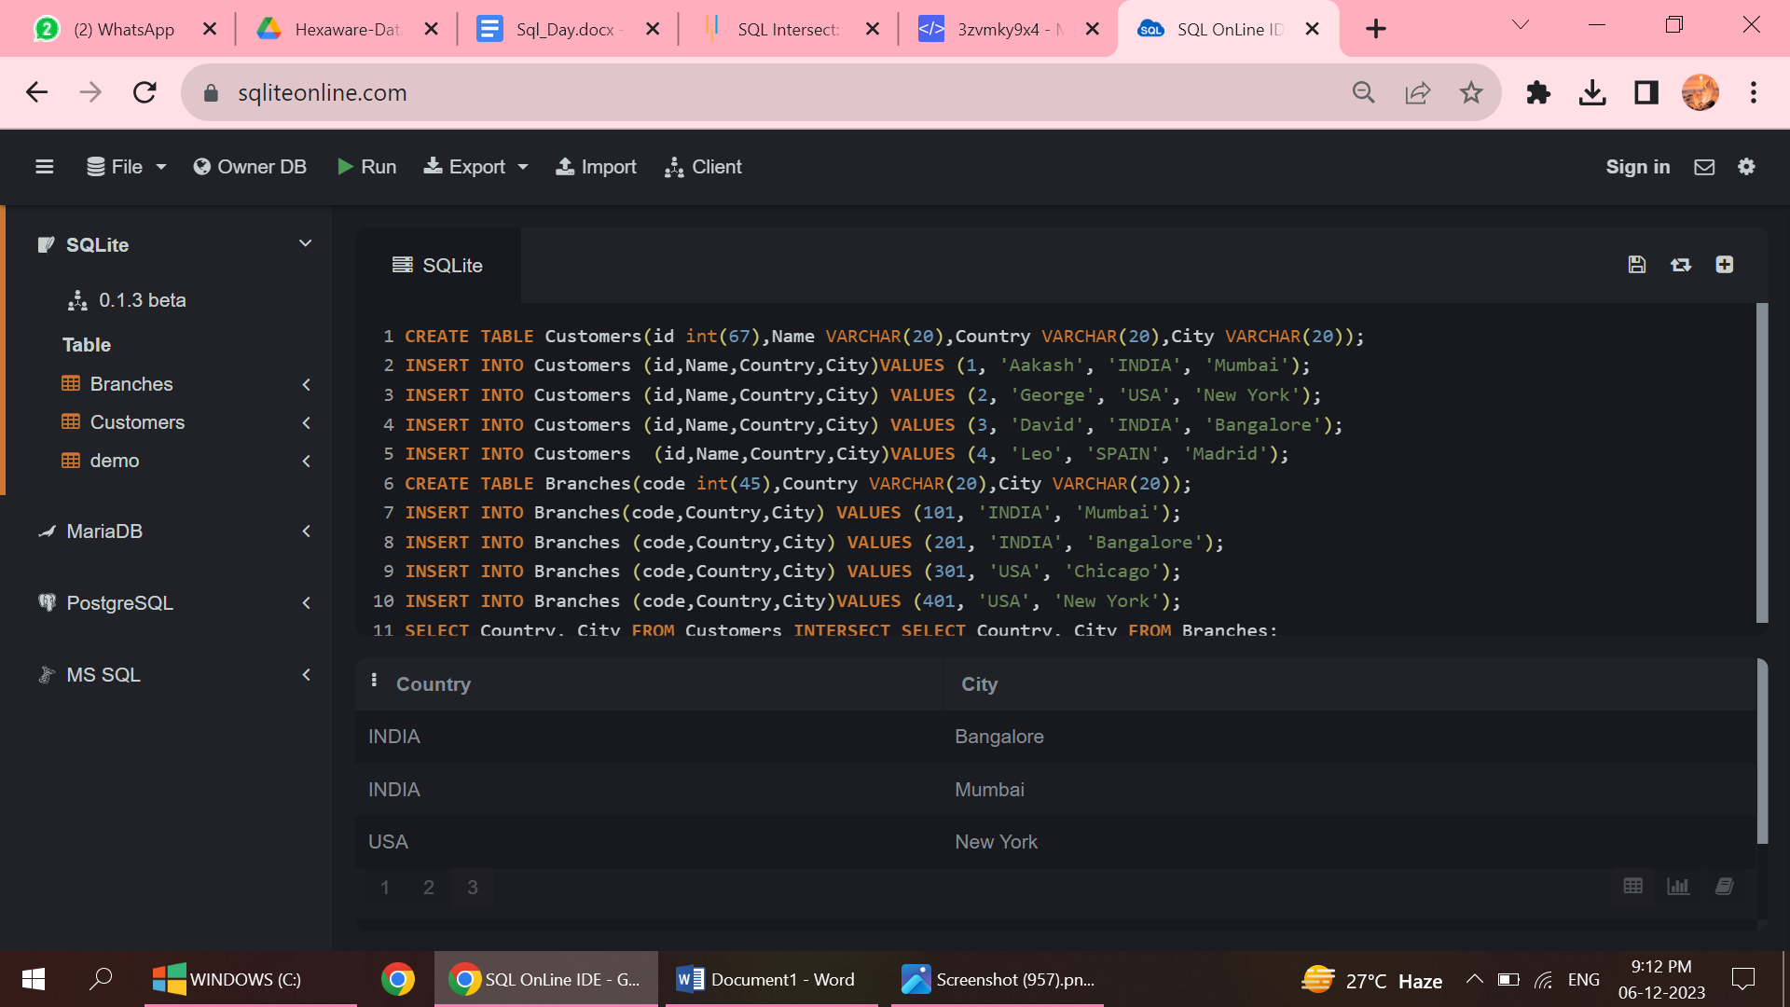

4.EXCEPT

* The command combines both the tables, the left side table of except command is considered and right side table of except is not considered.
* The values that are common in both the side tables are removed.
* Duplicate values are also removed.

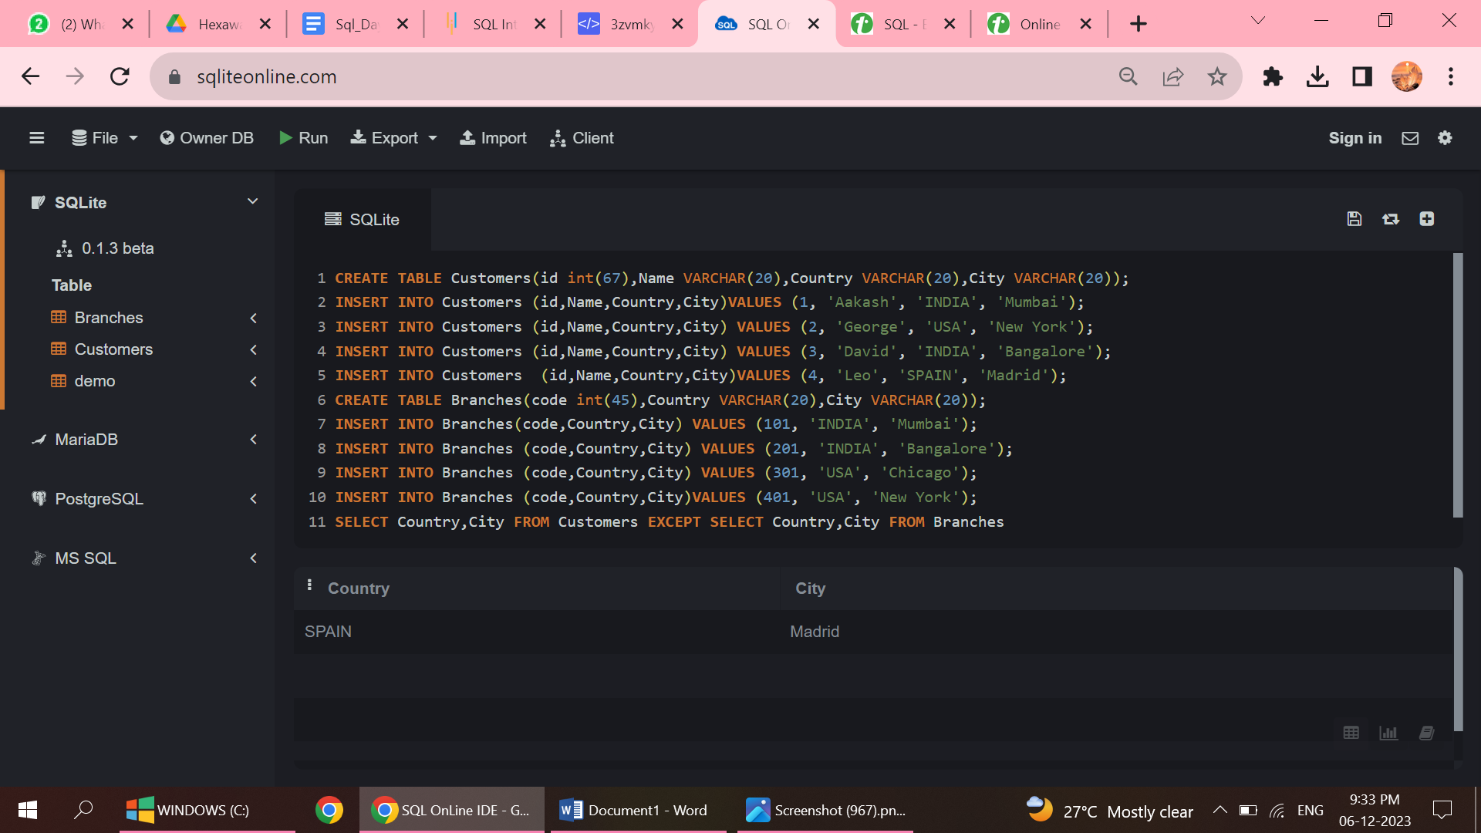

CONSTRAINTS

1.DEFAULT

* There is no need of inserting any value for the column with default constraint.

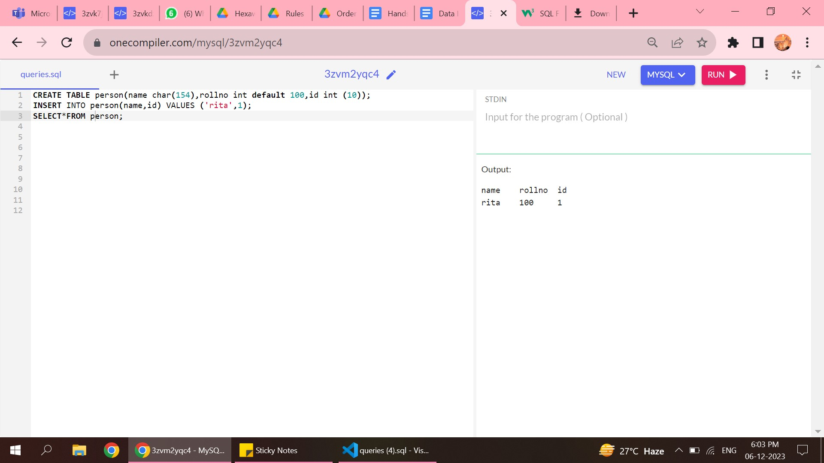

2.UNIQUE KEY

* The unique key is mentioned then that column should contain different values.
* No two column with unique key constraint should have same value.

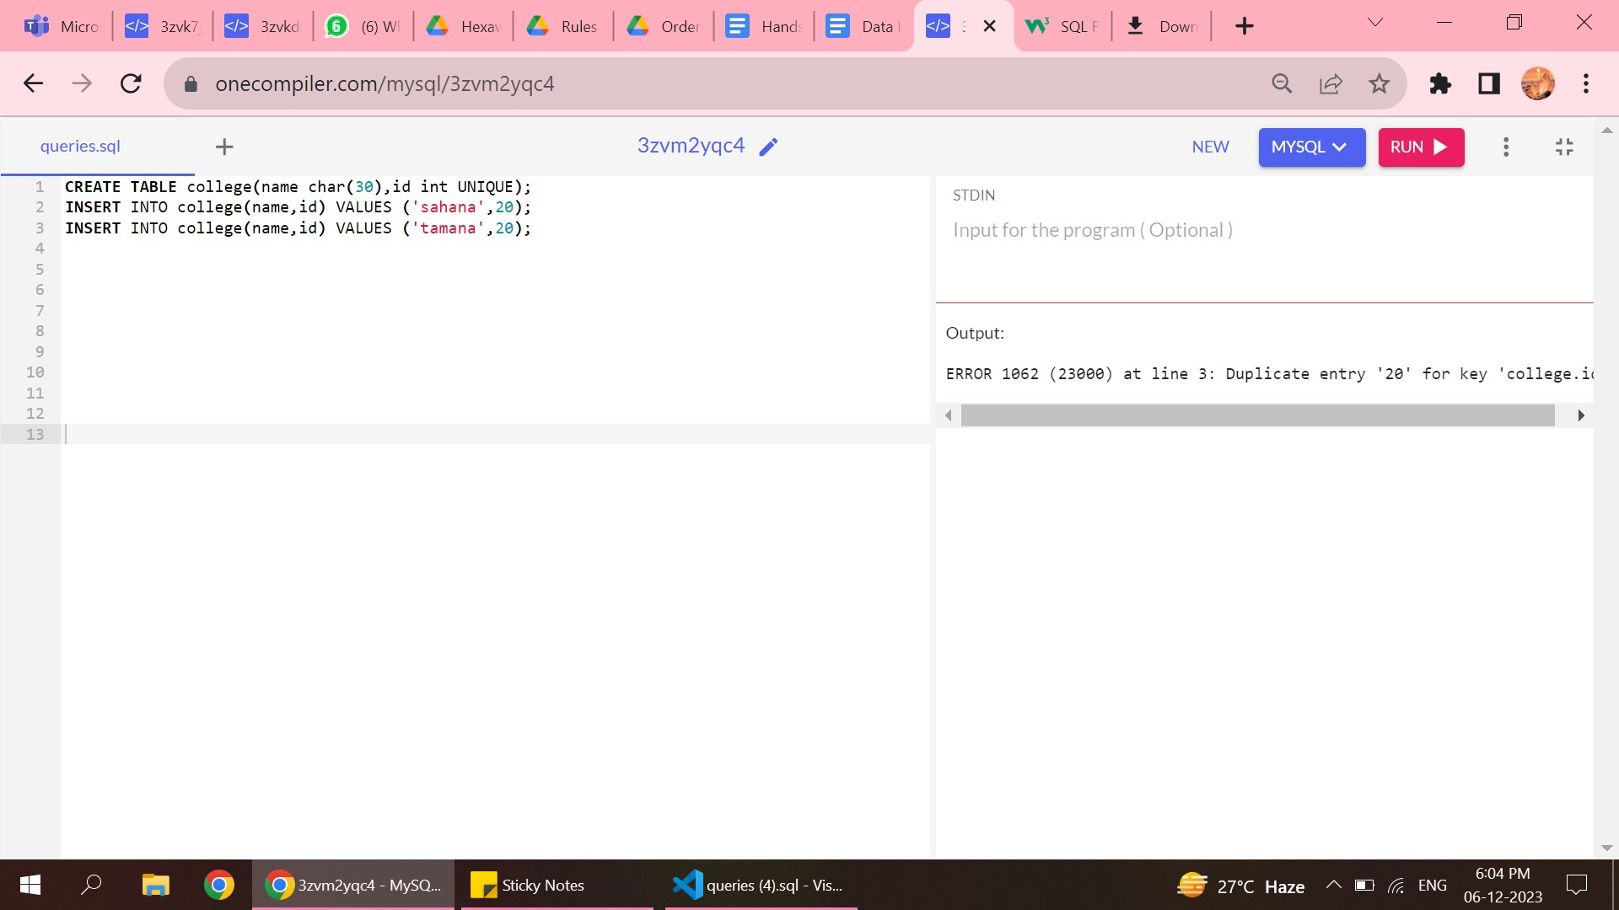

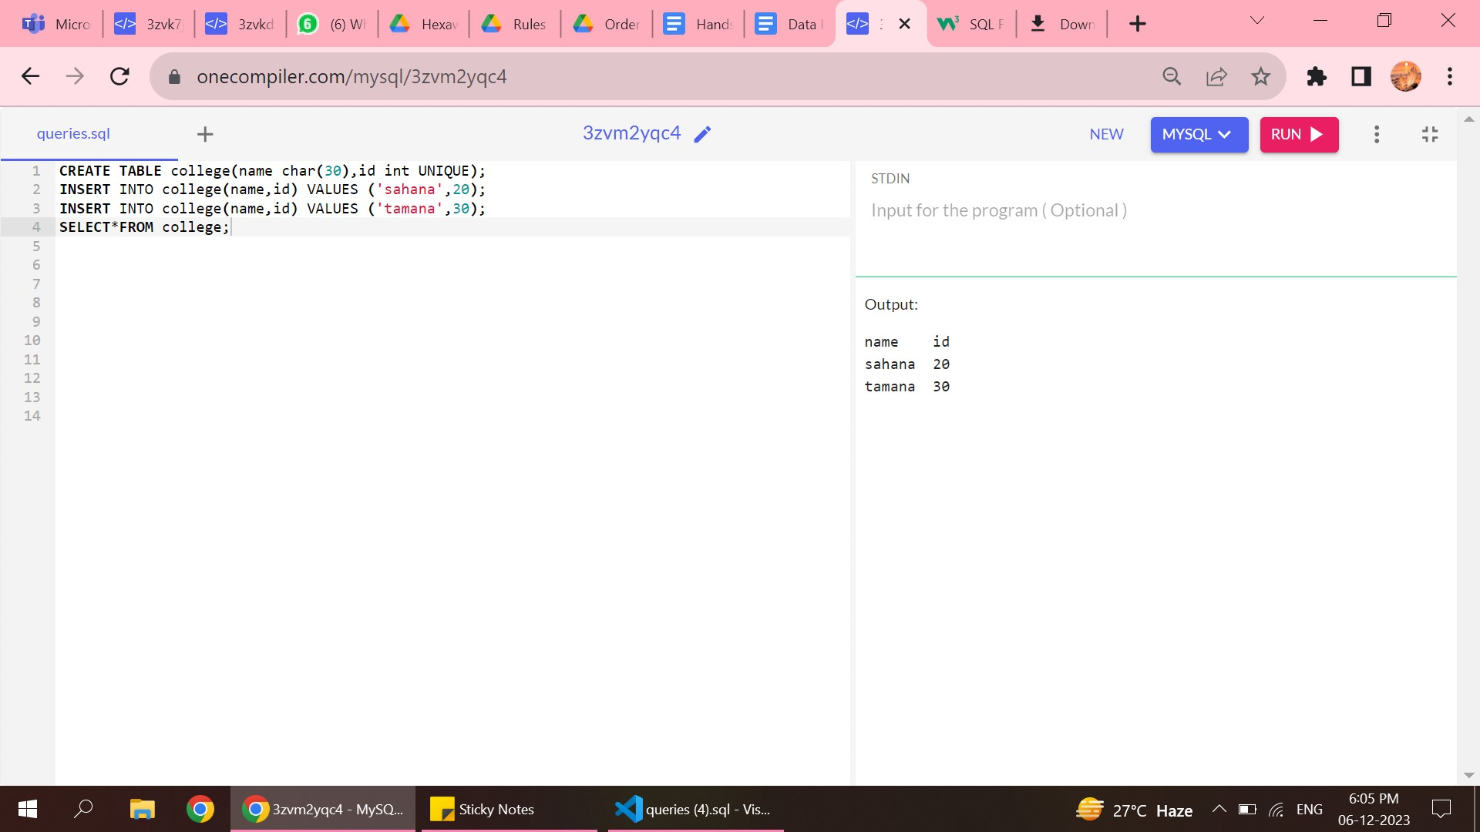

3.NOT NULL CONSTRIANT

* This column should not have null values.

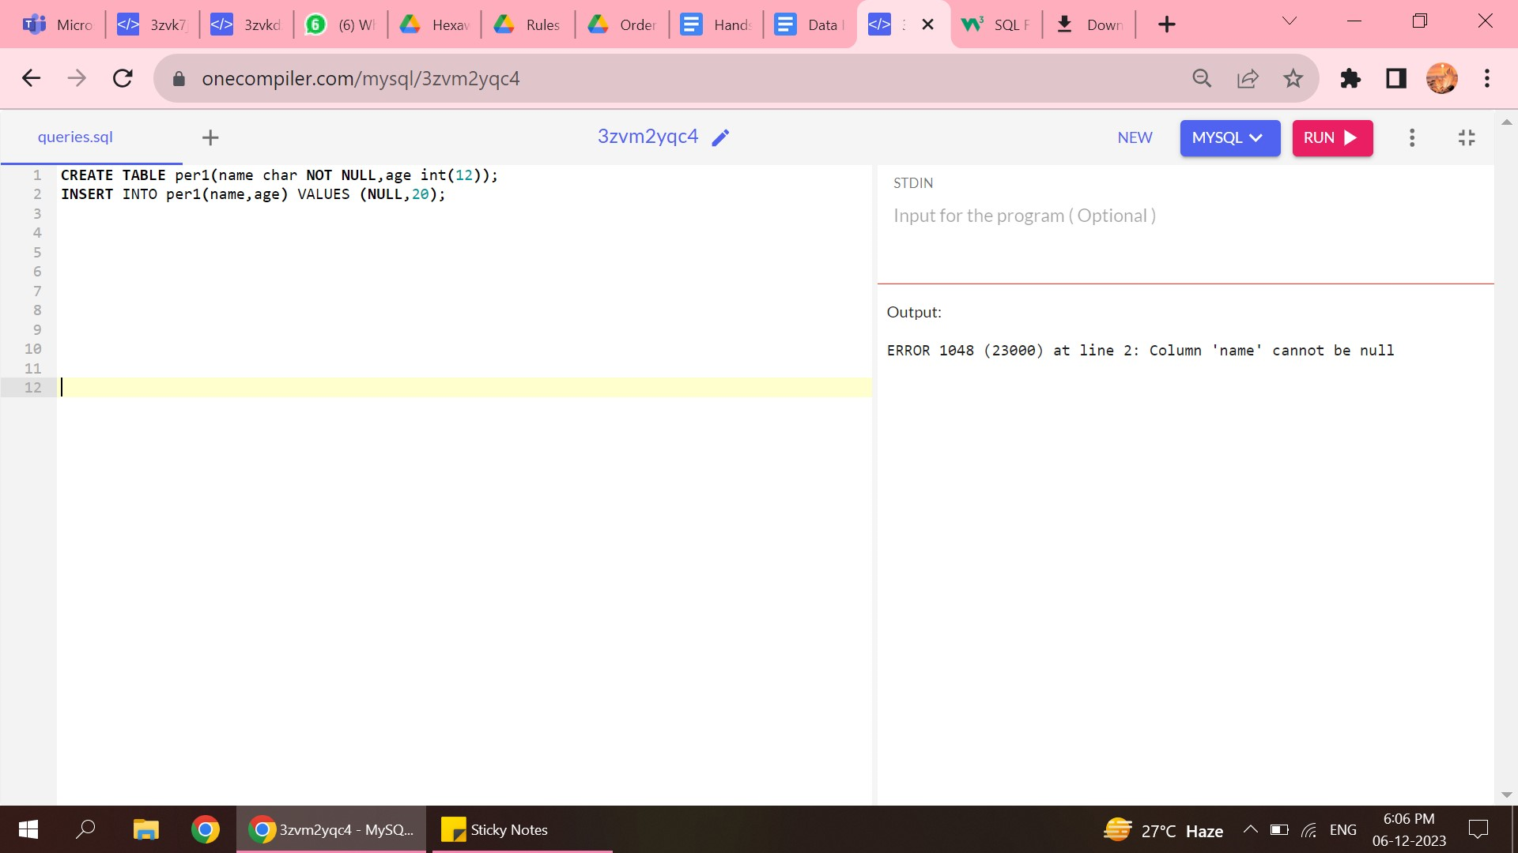

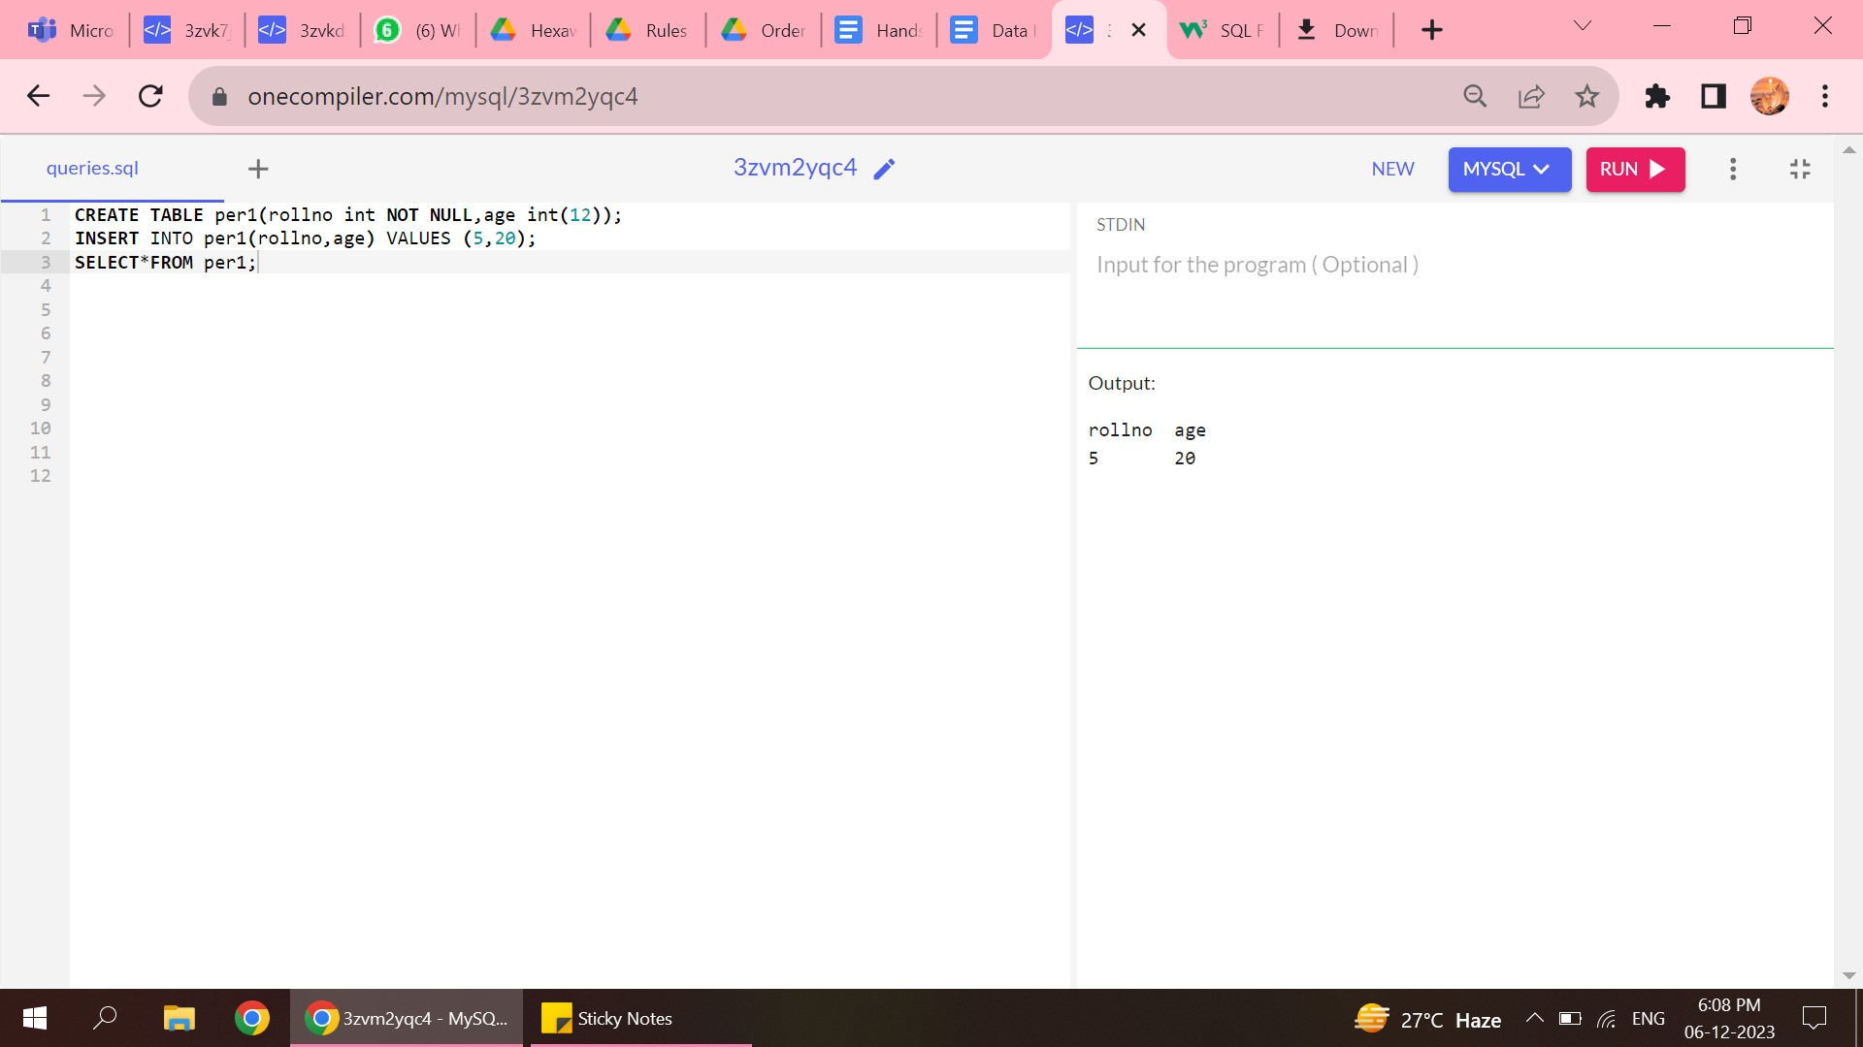

4.PRIMARY KEY

* The value of primary key should not be null.
* The value should not be repeated ,values should be unique.

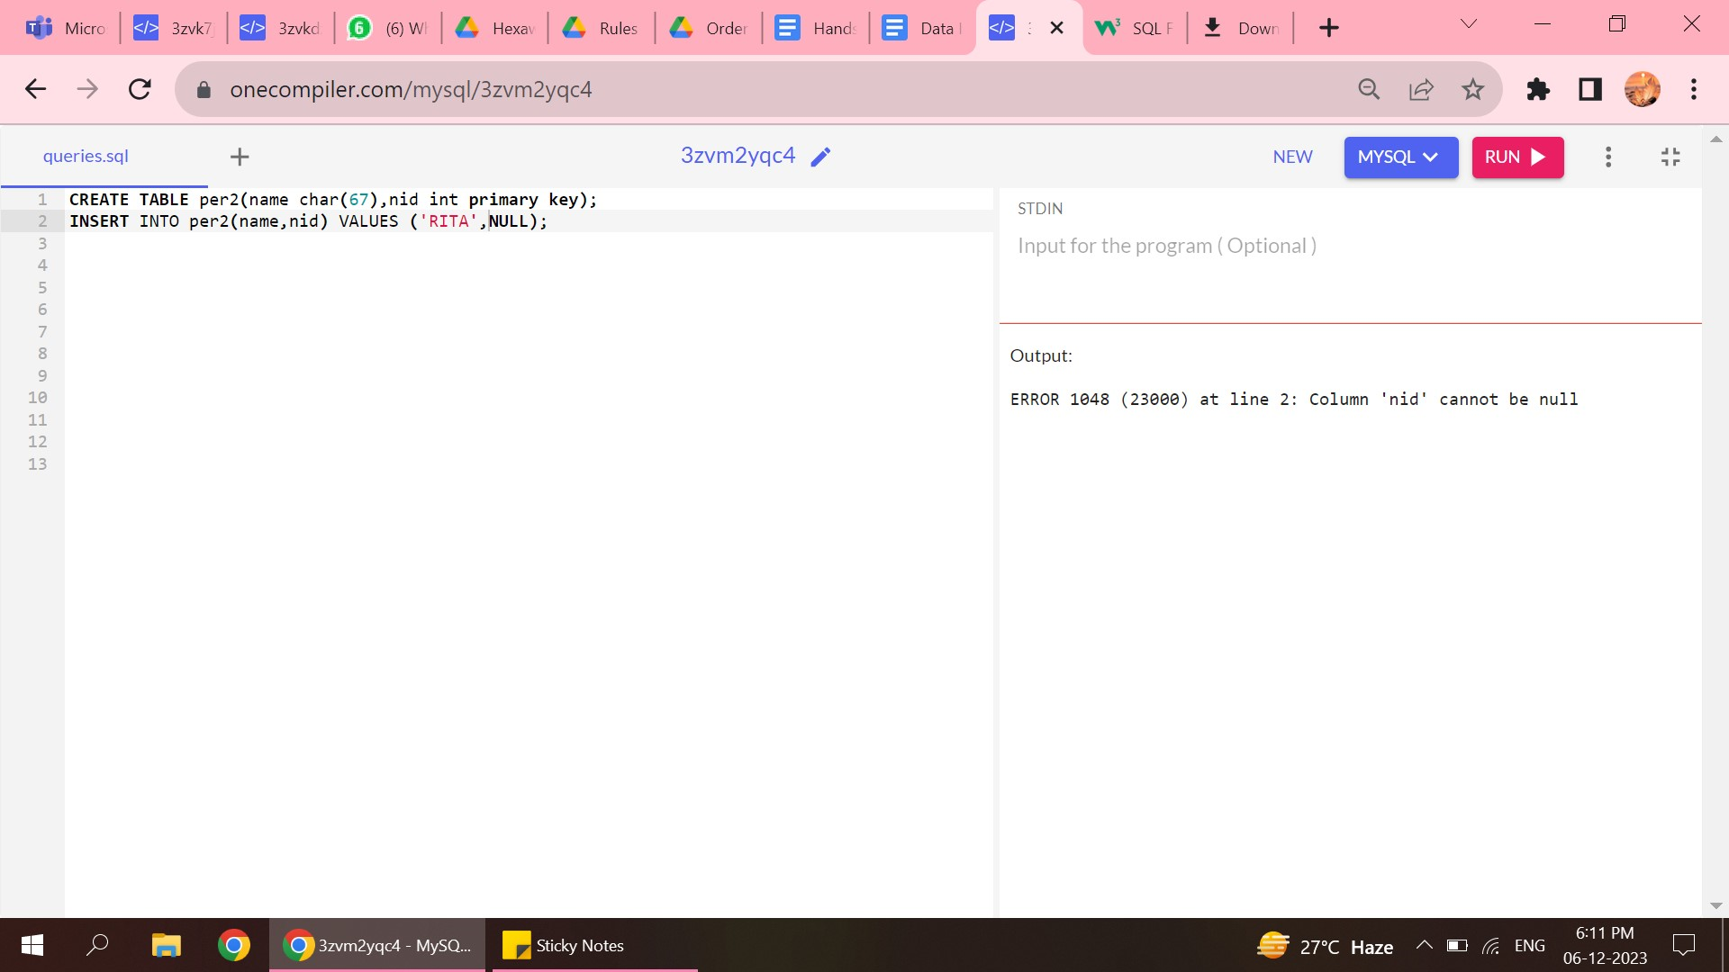

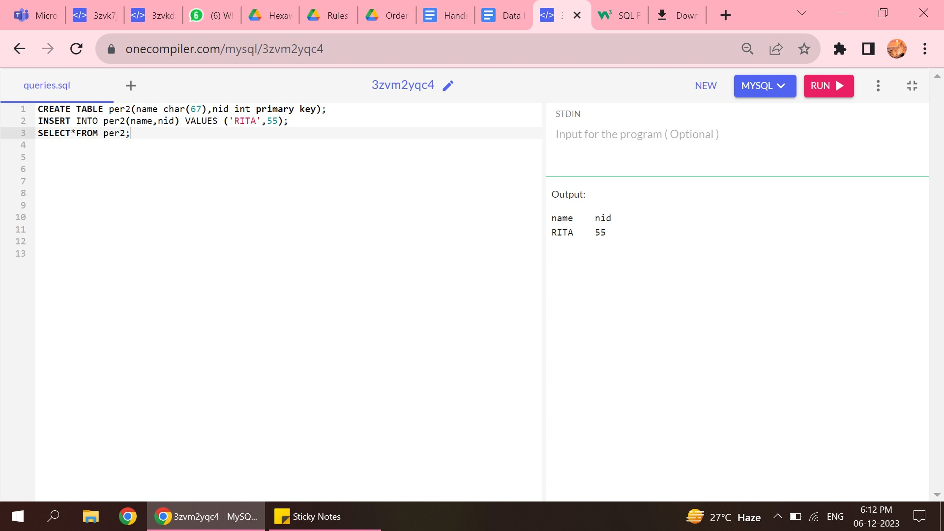

5.CHECK CONSTRAINT

* The check constraint allows the entire column to contain values that are already specified in the condition.

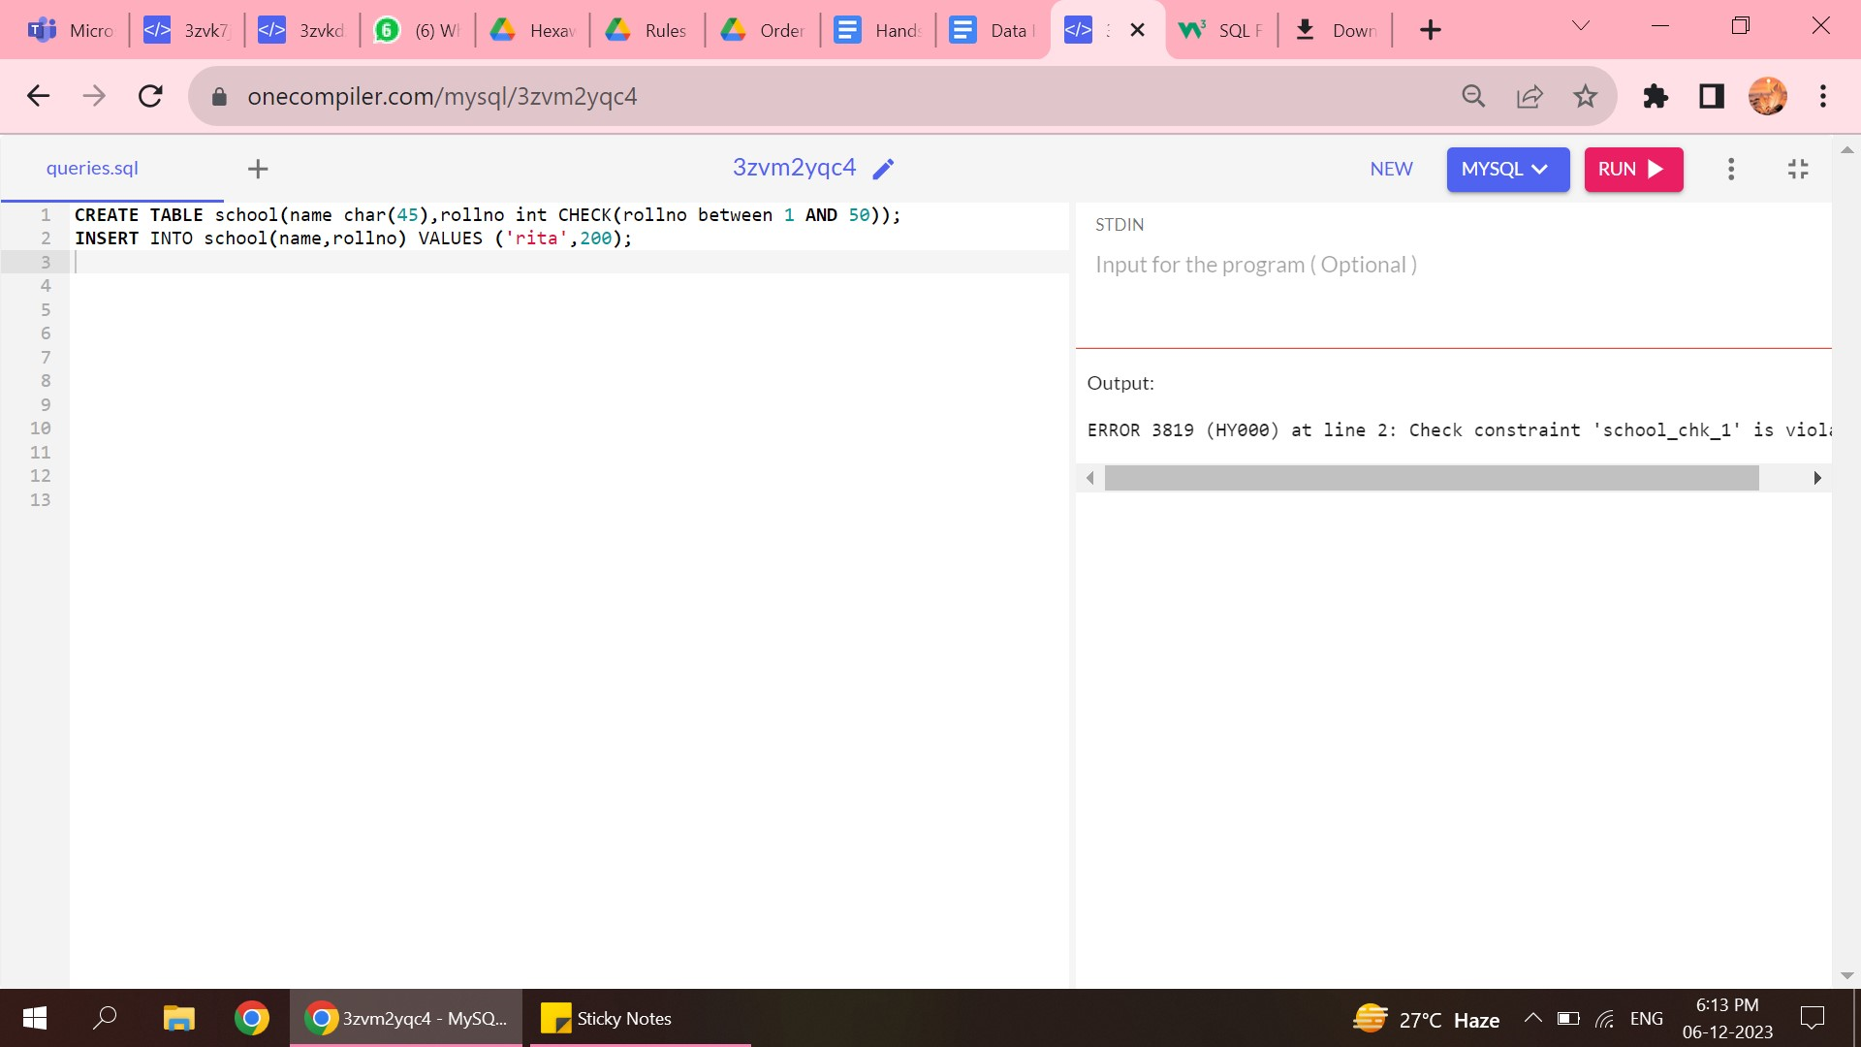

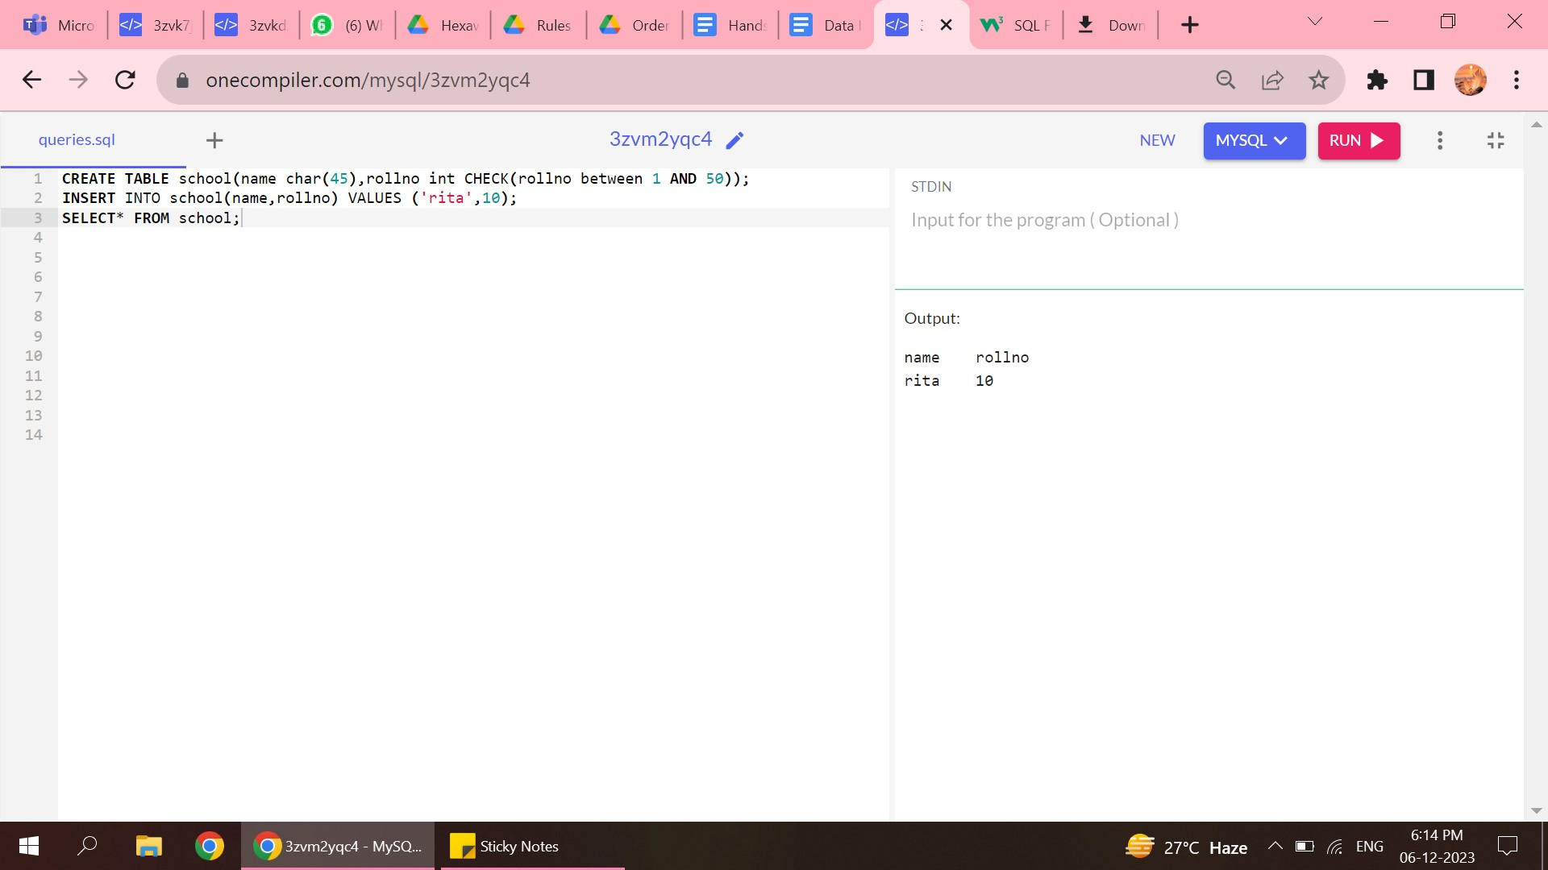

6.FORIEGN KEY

* There are two tables created, the first table contains the primary key and this primary key act as the key for the next table .
* This primary key is referred as foreign key in another table.
* The primary key and Foreign key should have same value otherwise the tables cannot be matched.

